academia英語編 (▶ p.241)  Basic Laboratory Skills | 年 組 番  名前 | 主体的な態度  A・B・C

Safety glasses should be worn at all times while in the laboratory.
保護メガネ
実験室
その間
着用
To weigh a compound using an electronic balance

①Place a beaker on an electronic balance.
②Adjust the zero-
point.
③Place the
Compound into
The beaker.

②Adjust the zero-point.
③Place the compound into the beaker.
計量
化合物
電子天びん
Bunsen Burner and Flame Reactions
Lithium Li

Sodium Na

Potassium K

反応
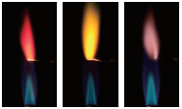

調整

合成物


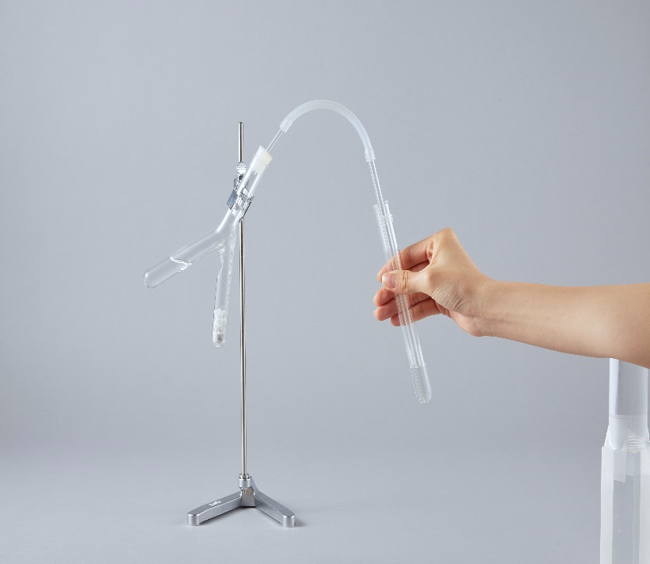
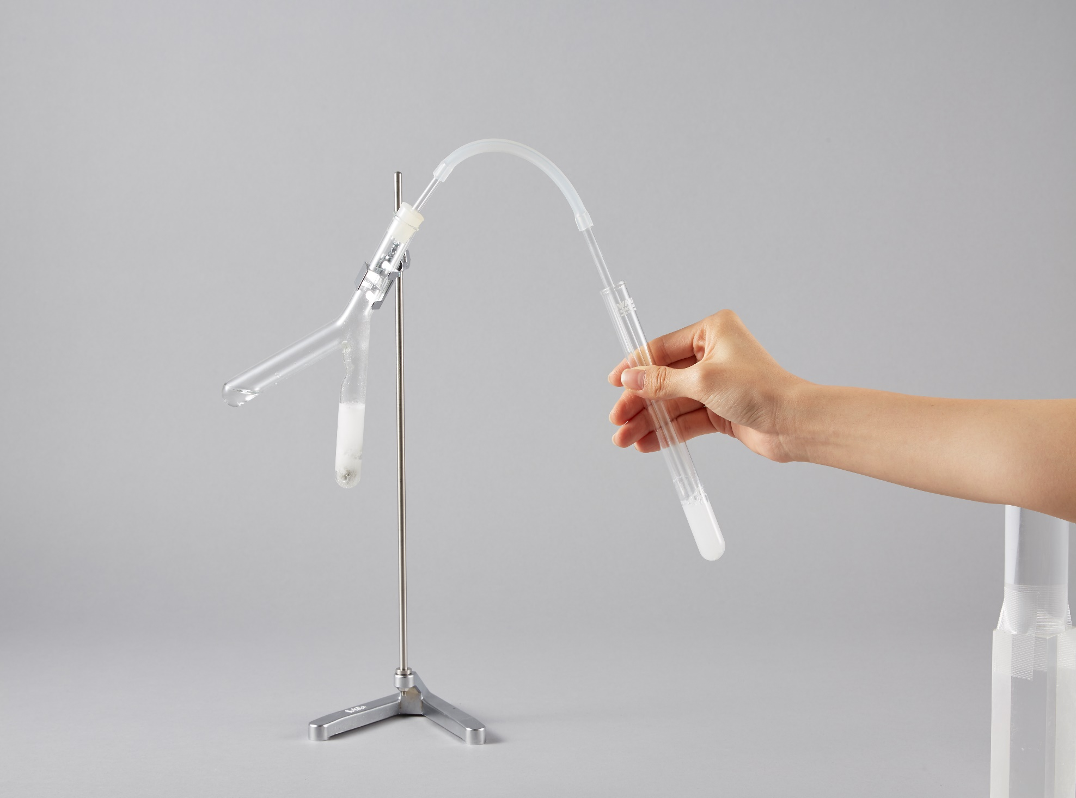
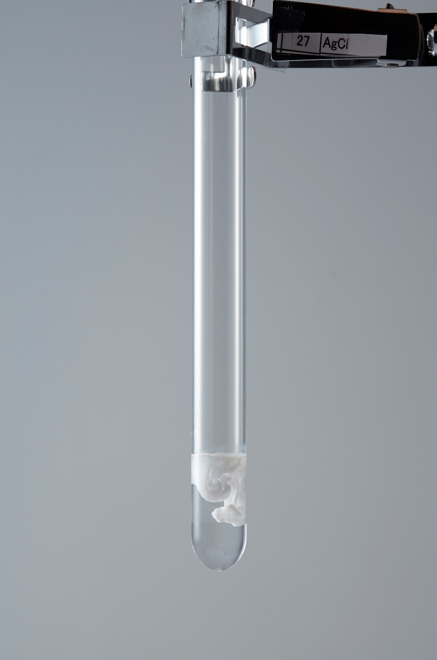
Detection of Carbon
Hydrochloric
acid

Limewater

Becomes cloudy.

Limewater
Calcium carbonate
CaCO₃

検出
塩酸
炭酸塩
～になる
Detection of Chloride (ions)
Add a few drops of Silver nitrate AgNO₃ solution.

Precipitate of
silver chloride AgCl

Sodium chloride NaCl
solution

追加
少し
硝酸銀（nitrate:硝酸塩）
沈殿物
塩化
ナトリウム
塩化物

● Questions

１．Which experiments shown above have to be carried out to distinguish sugar from salt?
Flame Reactions and Chloride Detection
２．Which of the following statements Ca(OH)₂ is true？
① It shows orange flame in the flame reaction.
② Precipitation is observed when an aqueous solution AgNO₃ is added.
③ The aqueous solution becomes cloudy when CO₂ is passed through.
③

Distillation A method of separating and purifying liquids by use of their boiling point differences. Vapors are cooled separately at different temperature and the resulting liquids are collected independently in their pure form.
蒸留

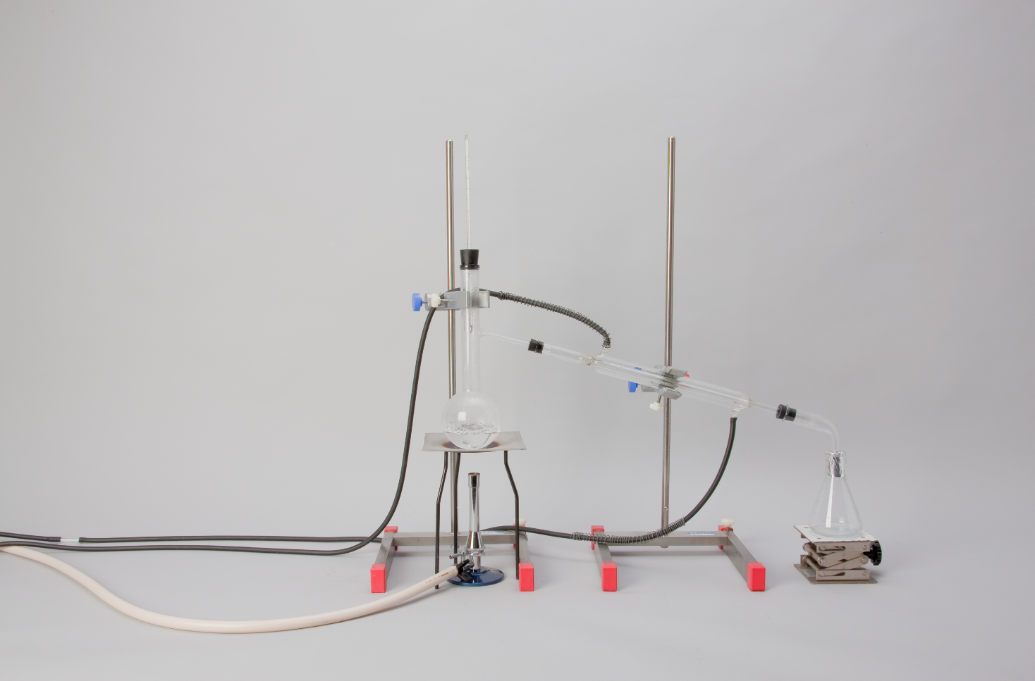
金網
ガスバーナー
留め金
Thermometer
Distilling flask
Wire gauze
Bunsen burner
Cold water out
Tripod
Cold water in
Clamp
Liebig condenser
Adapter
Receiving
flask
温度計
枝付きフラスコ
冷水を抜く
Mixture
混合物
冷水を入れる
三脚
リービッヒ冷却器
アダプター

● Questions

１． What is collected in the receiving flask when seawater is distilled?
Water
２． In case of distillation, the vapor is cooled to liquid in the Liebig condenser. What is called this change of state?

Condensation

Column chromatography
A method of separating mixtures through a column in of silica gel or alumina by use of the differences in their adsorption forces.
カラムクロマトグラフィー
通って
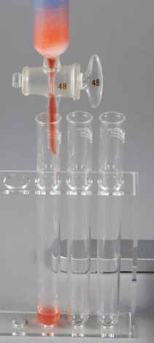
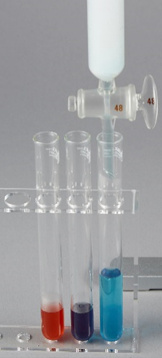
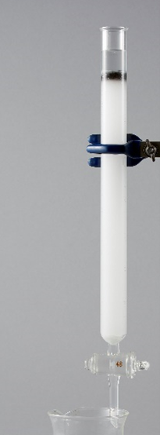
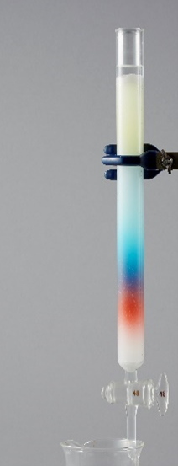
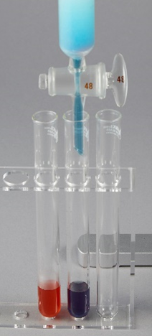
インク
分離された
インク成分
Column
Solvent
Ink
Silica gel
Glass
wool
Separated
ink
components

Solvent
シリカゲル
ガラス
ウール
溶剤
酸化アルミニウム
吸着力

academia英語編 (▶ p.241)  Basic Laboratory Skills | 年 組 番  名前 | 主体的な態度  A・B・C

Safety glasses should be worn at all times while in the laboratory.
保護メガネ
実験室
その間
着用
To weigh a compound using an electronic balance

①Place a beaker on an electronic balance.
②Adjust the zero-
point.
③Place the
Compound into
The beaker.

②Adjust the zero-point.
③Place the compound into the beaker.
計量
化合物
電子天びん
Bunsen Burner and Flame Reactions
Lithium Li

Sodium Na

Potassium K

反応

調整

合成物

Detection of Carbon
Hydrochloric
acid

Limewater

Becomes cloudy.

Limewater
Calcium carbonate
CaCO₃

検出
塩酸
炭酸塩
～になる
Detection of Chloride (ions)
Add a few drops of Silver nitrate AgNO₃ solution.

Precipitate of
silver chloride AgCl

Sodium chloride NaCl
solution

追加
少し
硝酸銀（nitrate:硝酸塩）
沈殿物
塩化
ナトリウム
塩化物

● Questions

１．Which experiments shown above have to be carried out to distinguish sugar from salt?
Flame Reactions and Chloride Detection
２．Which of the following statements Ca(OH)₂ is true？
① It shows orange flame in the flame reaction.
② Precipitation is observed when an aqueous solution AgNO₃ is added.
③ The aqueous solution becomes cloudy when CO₂ is passed through.
③

Distillation A method of separating and purifying liquids by use of their boiling point differences. Vapors are cooled separately at different temperature and the resulting liquids are collected independently in their pure form.
蒸留

金網
ガスバーナー
留め金
Thermometer
Distilling flask
Wire gauze
Bunsen burner
Cold water out
Tripod
Cold water in
Clamp
Liebig condenser
Adapter
Receiving
flask
温度計
枝付きフラスコ
冷水を抜く
Mixture
混合物
冷水を入れる
三脚
リービッヒ冷却器
アダプター

● Questions

１． What is collected in the receiving flask when seawater is distilled?
Water
２． In case of distillation, the vapor is cooled to liquid in the Liebig condenser. What is called this change of state?

Condensation

Column chromatography
A method of separating mixtures through a column in of silica gel or alumina by use of the differences in their adsorption forces.
カラムクロマトグラフィー
通って
インク
分離された
インク成分
Column
Solvent
Ink
Silica gel
Glass
wool
Separated
ink
components

Solvent
シリカゲル
ガラス
ウール
溶剤
酸化アルミニウム
吸着力

