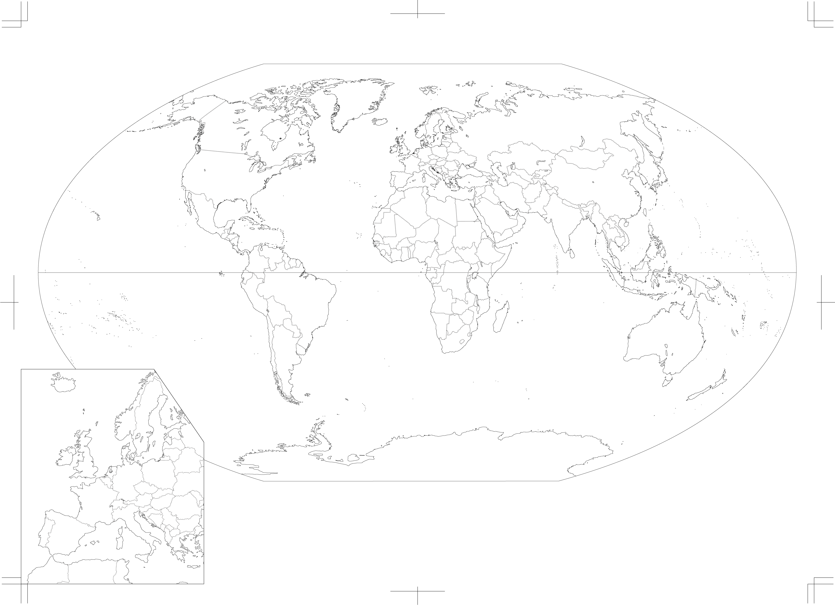

|  |  |  |  |
| --- | --- | --- | --- |
| ❶ |  | **洋** | |
| ❷ |  | **洋** | |
| ❸ |  | **洋** | |
| ❹ |  | | |
| ❺ |  | | **海** |
| ❻ |  | | **海** |
| ❼ |  | | **海** |
| ❽ |  | | **大陸** |

|  |  |
| --- | --- |
| **アフリカ大陸** | |
| ⑲ |  |
| ⑳ |  |
| ㉑ |  |
| ㉒ |  |
| ㉓ |  |

|  |  |  |  |  |  |  |  |
| --- | --- | --- | --- | --- | --- | --- | --- |
| **ユーラシア大陸** | | | | | | | |
| **ヨーロッパ大陸** | | | | **中東** | | **アジア大陸** | |
| ㉔ |  | ㉚ |  | ㊱ |  | ㊷ |  |
| ㉕ |  | ㉛ |  | ㊲ |  | ㊸ |  |
| ㉖ |  | ㉜ |  | ㊳ |  | ㊹ |  |
| ㉗ |  | ㉝ |  | ㊴ |  | ㊺ |  |
| ㉘ |  | ㉞ |  | ㊵ |  | ㊻ |  |
| ㉙ |  | ㉟ |  | ㊶ |  | ㊼ |  |
|  | | | | | | ㊽ |  |

|  |  |
| --- | --- |
| **オセアニア** | |
| ㊾ |  |
| ㊿ |  |

|  |  |  |  |
| --- | --- | --- | --- |
| **アメリカ大陸** | | | |
| **北アメリカ** | | **南アメリカ** | |
| ⑨ |  | ⑭ |  |
| ⑩ |  | ⑮ |  |
| ⑪ |  | ⑯ |  |
| **中央アメリカ** | | ⑰ |  |
| ⑫ |  | ⑱ |  |
| ⑬ |  |

❼

㉟

⑩

㊲

㊸

⑨

㊵

㊴

㊷

❻

㊱

㉑

⑲

⑪

❺

㊶

⑫

㊼

㊳

⑳

❷

㊻

㊹

⑬

❶

㊽

㉓

⑭

❸

㊺

❹

⑯

⑮

㊾

㉒

⑰

⑱

㊿

㉙

㉝

㉗

❽

㉔

㉚

㉞

㉜

㉘

㉛

㉖

㉕